PROJECT DOCUMENTATION
AnswerBot – AI-Powered FAQ and Customer Support Automation

Team ID: SWTID-2026-2922
Team Size: 5
Team Leader : SUPRIYA B
Email: 000supriyababy000@gmail.com
Team member : SUPRAJA T
Email: tsupraja759@gmail.com
Team member : SOWNDARYA S
Email: sowndarya2321@gmail.com
Team member : SUBHASRI G
Email: subhasrigandhi0029@gmail.com
Team member : SOWMIYA M
Email: sowmiyamahendran1206@gmail.com
1. INTRODUCTION
AnswerBot is a backend-based AI FAQ and customer support system developed using Node.js, Express.js, MongoDB, and Mongoose.
The system allows users to securely register, login, create and manage FAQs, search FAQ content, and generate FAQ answers using Google Gemini AI.
JWT is used for authentication and bcrypt is used for password encryption.

2. PROJECT INSTRUCTION
AnswerBot follows a RESTful API architecture.
The main functions are:
- User registration and login
- JWT authentication
- FAQ management
- FAQ search
- Category organization
- AI FAQ generation
- MongoDB data storage

3. PROJECT OVERVIEW
AnswerBot provides a centralized platform for managing frequently asked questions.
Users can:
- Create FAQs
- View FAQs
- Update FAQs
- Delete FAQs
- Search FAQs
- Generate FAQs using AI
The system reduces manual work in customer support and keeps FAQ information organized.

4. PROJECT ARCHITECTURE
AnswerBot follows a layered architecture.
1. Interface Layer
Handles API requests through Postman or other API clients.
2. Application Layer
Contains routes, controllers, middleware, authentication, and business logic.
3. Data Layer
Uses MongoDB and Mongoose for storing and managing data.
4. AI Layer
Uses Google Gemini AI for generating FAQ content.
Flow:
Client → Express → Middleware → Controller → MongoDB / AI → Response

5. PRE-REQUISITES
Software | Purpose
Node.js | Backend runtime
npm | Package management
MongoDB | Database
Mongoose | Database connection
VS Code | Code editor
Postman | API testing

6. KNOWLEDGE REQUIREMENTS
Developers should have basic knowledge of:
- JavaScript
- Node.js
- Express.js
- MongoDB
- REST API
- JWT
- bcrypt
- API testing

7. ER DIAGRAM
AnswerBot mainly contains the following entities:
User
- User ID
- Name
- Email
- Password
- Role
FAQ
- FAQ ID
- Question
- Answer
- Category
- Created By
Category
- Category Name
- Description
- Total FAQs
Relationship
User (1) → (Many) FAQ
One user can create multiple FAQs.
Category (1) → (Many) FAQ
One category can contain multiple FAQs.

8. TECHNICAL ARCHITECTURE
Controllers
Handle application business logic.
Models
Define MongoDB data structures using Mongoose.
Routes
Define API endpoints.
Middleware
Handles:
- JWT authentication
- Validation
- Error handling
- Security
Configuration
Stores environment variables such as MongoDB URL and API keys.

9. FEATURES
- User Authentication – Secure registration and login.
- FAQ Management – Create, read, update, and delete FAQs.
- AI FAQ Generation – Generate FAQ content using Gemini AI.
- FAQ Search – Search FAQs using keywords.
- Category Management – Organize FAQs into categories.
- Password Security – Passwords are hashed using bcrypt.
- MongoDB Integration – Stores application data.
- REST API – Provides structured backend services.

10. ROLES AND RESPONSIBILITIES
Admin
- Manage users
- Manage FAQs
- Manage categories
- Monitor AI-generated content
Content Creator
- Create FAQs
- Edit FAQs
- Delete own FAQs
- Generate FAQs using AI
Authenticated User
- View FAQs
- Search FAQs
- Generate AI answers
Public User
- View public FAQs
- Search FAQs

11. USER FLOW
- User opens the application.
- User registers an account.
- User logs in.
- JWT token is generated.
- User accesses protected features.
- User creates and manages FAQs.
- User searches FAQs.
- User can generate FAQ content using AI.

12. PROJECT SETUP
Create the project folder and initialize Node.js:
npm init -y
Install dependencies:
npm install express mongoose dotenv cors jsonwebtoken bcrypt @google/genai
Folder Structure
AnswerBot
│
├── src
│ ├── server.js
│ ├── app.js
│ ├── middleware
│ ├── models
│ └── routes
│
├── .env
└── package.json

13. BACKEND DEVELOPMENT
The backend is developed using Node.js and Express.js.
Main components:
- server.js – Starts the server.
- app.js – Configures Express.
- authMiddleware.js – Verifies JWT.
- errorMiddleware.js – Handles errors.
- User.js – User schema.
- FAQ.js – FAQ schema.
- Routes – Handle API requests.

14. DATABASE DEVELOPMENT
AnswerBot uses MongoDB as the database.
Users Collection
- _id
- name
- email
- password
- role
- createdAt
- updatedAt
FAQs Collection
- _id
- question
- answer
- category
- createdBy
- createdAt
- updatedAt

15. CONFIGURE MONGODB
MongoDB is connected using Mongoose.
The MongoDB connection string is stored in the .env file.
Example:
MONGO_URI=your_mongodb_connection_string
PORT=5000
JWT_SECRET=your_secret_key
GEMINI_API_KEY=your_api_key

16. API ENDPOINTS
Register
POST /api/auth/register
Login
POST /api/auth/login
Create FAQ
POST /api/faqs
Search FAQ
GET /api/faqs/search?q=configure
Generate FAQ
POST /api/ai/generate-faq

17. PROJECT EXECUTION
Start the application using:
npm run dev
The APIs can be tested using Postman or Thunder Client.

Execution 1 – Register
POST /api/auth/register
{
"name": "Priya Sharma",
"email": "priya@writeflow.com",
"password": "securepassword123"
}
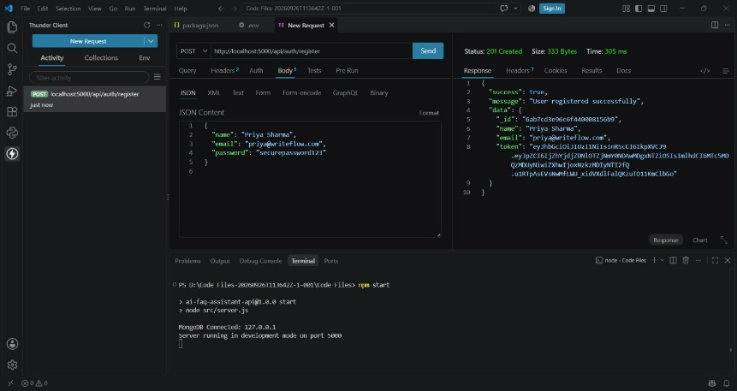

Execution 2 – Login
POST /api/auth/login
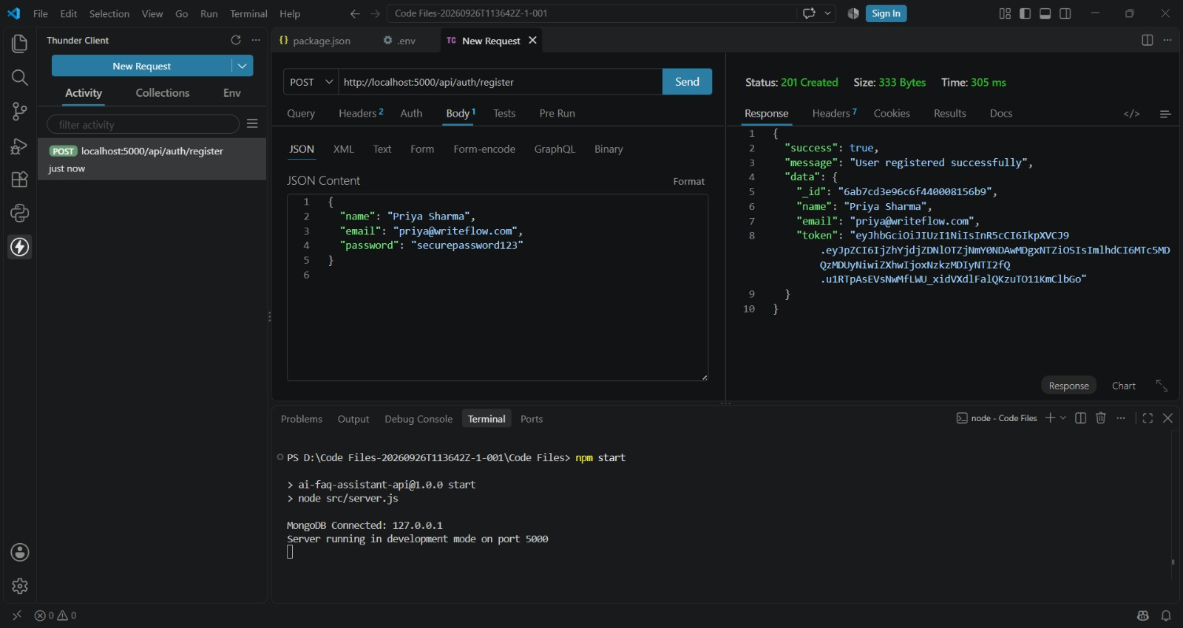
Execution 3 – Create FAQ
POST /api/faqs
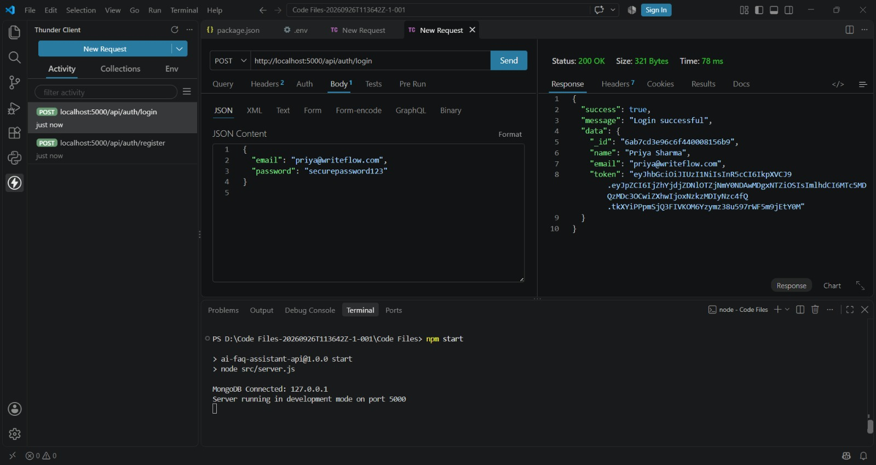

Execution 4 – Search FAQ
GET /api/faqs/search?q=configure
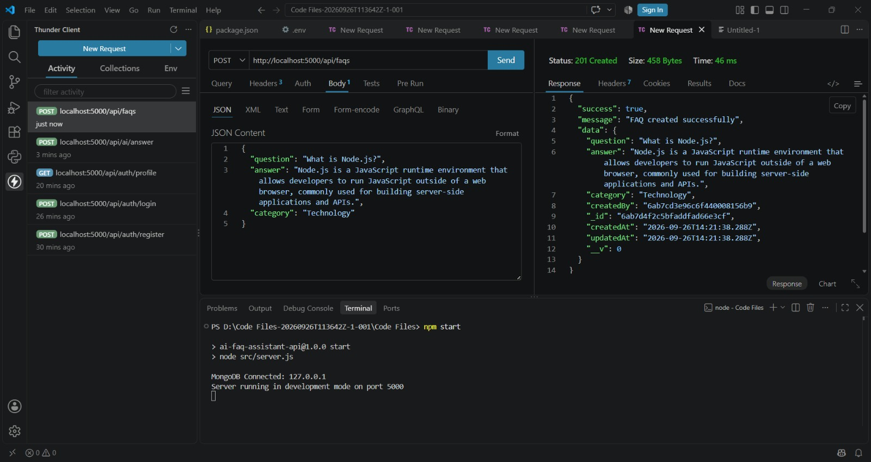

Execution 5 – Generate FAQ
POST /api/ai/generate-faq
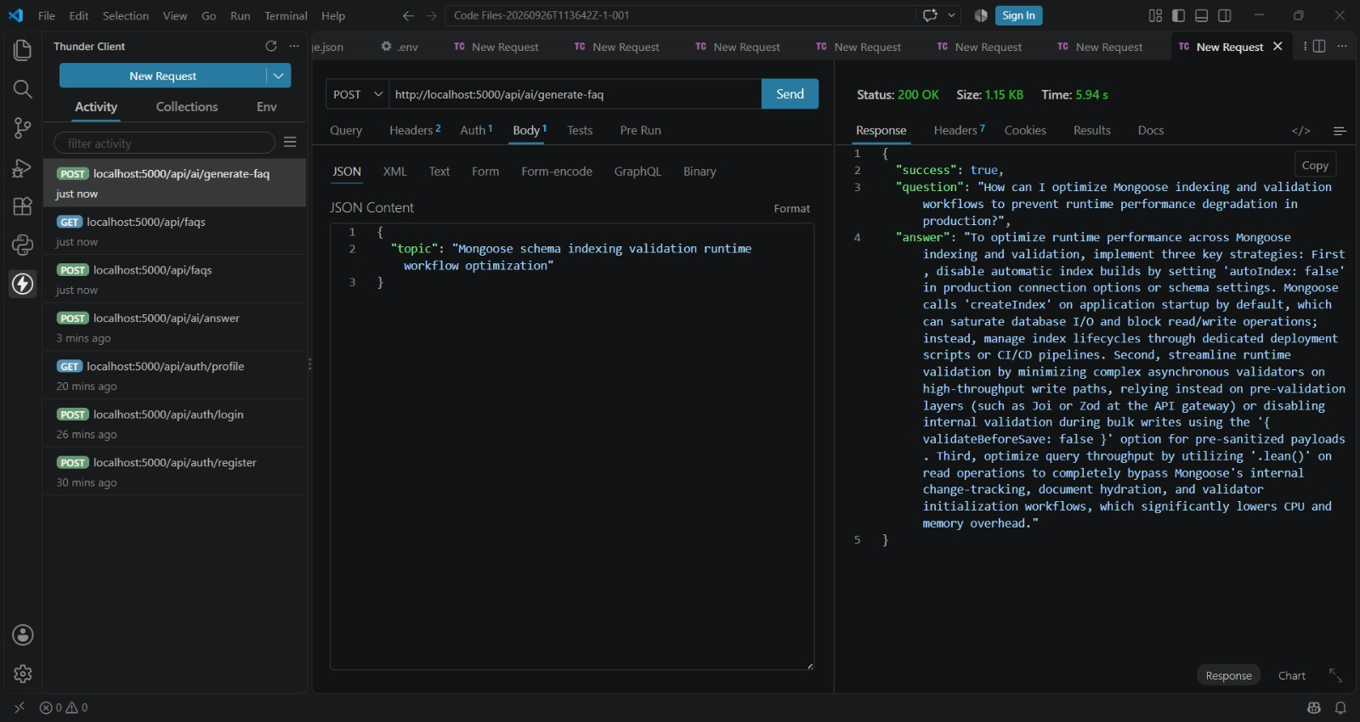

18. PROJECT EXECUTION STEPS
- Open the project folder.
- Install dependencies.
- Configure .env.
- Connect MongoDB.
- Start the server.
- Register a user.
- Login and obtain JWT.
- Test FAQ operations.
- Test FAQ search.
- Test AI FAQ generation.

19. ABSTRACT
AnswerBot is an AI-powered FAQ and customer support automation system developed using Node.js, Express.js, MongoDB, Mongoose, JWT, bcrypt, and Google Gemini AI.
The system provides secure authentication, FAQ CRUD operations, search functionality, category organization, and AI-based FAQ generation.
The project follows RESTful API architecture and provides a centralized solution for managing FAQ and customer-support information.

:

